

**Grade VI Chapter: Locating places on Earth I. Date:4.6.25**

**I. Vocabulary**

1. **Globe** – A small model of the Earth showing continents, oceans, and countries.
2. **Map** – A drawing of the Earth's surface or part of it on a flat surface.
3. **Atlas** – A collection of maps bound in the form of a book.
4. **Scale** – The ratio between the actual distance and the distance shown on a map.
5. **Compass** – A tool used to find direction on maps using cardinal points (North, South, East, West).
6. **Symbols** – Small signs or drawings used to represent features on a map.
7. **Latitude** – Imaginary horizontal lines that run around the Earth parallel to the Equator.
8. **Longitude** – Imaginary vertical lines that run from the North Pole to the South Pole.

**II. KWL Chart (Write your own)**

| **K – What I Know** | **W – What I Want to Know** | **L – What I Learned** |
| --- | --- | --- |
| A globe is round. | Why are maps not always accurate like globes? | A globe is more accurate for shape and size. |
| Directions are shown on maps. | What are the uses of symbols on a map? | Symbols help in reading maps easily. |
|  |  | . |

**III. Concept Map**

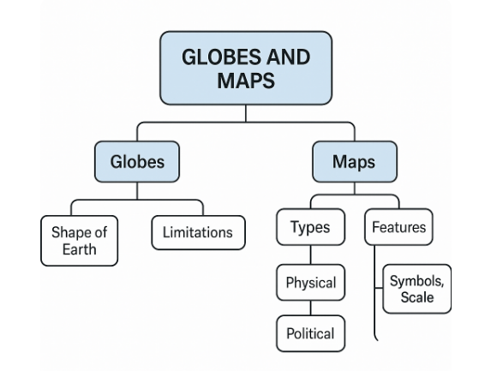 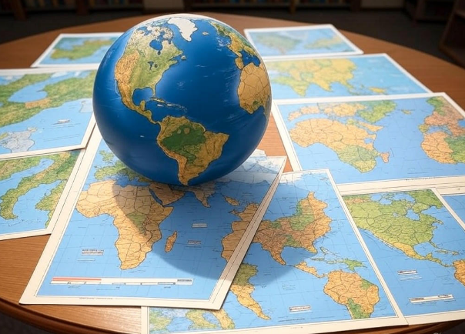

**IV. Questions**

**1. Define the following terms with examples:**  
a) Sketch  
b) Plan

**a) Sketch:**  
A sketch is a rough drawing of a place or area based on memory and observation. It is not drawn to scale.  
*Example: A student draws a sketch of their school showing classrooms, playground, and office.*

**b) Plan:**  
A plan is a detailed drawing of a small area, drawn to scale with accurate measurements.  
 *Example: A plan of a house showing the exact size and location of each room.*

**2. Differentiate between Globe and Map.**

|  |  |
| --- | --- |
| **Globe** | **Map** |
| 1. A globe is a spherical, 3D model of the Earth. | 1. A map is a flat, 2D representation of the Earth or a part of it. |
| 2. It shows the true shape, size, and position of continents and oceans. | 2. It may have distortions in shape and distance. |
| 3. It is not easy to carry and covers less detail. | 3. It is lightweight and portable, and can show detailed areas. |
| 4. A globe shows the whole Earth at once. | 4. A map can be focused on a specific area, like a city or state. |
| 5. It is used to understand Earth’s rotation and global structure. | 5. It is used for studying, navigation, and planning routes. |

**3. Explain the importance of direction and scale in maps.**

I. Direction helps us locate places correctly by using cardinal points (North, South, East, West) on a map.

II. Scale shows the relationship between map distance and actual ground distance, helping us measure how far places are from each other.

III. Both direction and scale make a map accurate and useful, allowing users to understand the layout and travel routes clearly.

**4. List 5 types of modern map used to locate and identify places using recent technology. Give one use of each?**  
**1. Satellite Maps**  
Use: Show actual images of Earth’s surface taken from space.

**2. GIS Maps (Geographic Information System)**  
Use: Combine layers of information (roads, population, water supply) for analysis.  
**3. Weather Maps (Live Weather Systems)**  
Use: Display live weather updates like storms, rainfall, and temperatures.  
**4. Augmented Reality (AR) Maps**  
 Use: Overlay map data on real-world views using a phone or AR glasses.

**5. 3D Maps**  
*Use:* Show hills, valleys, and elevations in three dimensions.

5. **Create Your Own Mini-Map!**

* You are at the school and want to go to your home, what route will you take? Name at prominent landmarks you have passed on the map.
* Add a **key/legend** and **compass rose** for direction.
* Label it clearly and use colors to make it attractive.

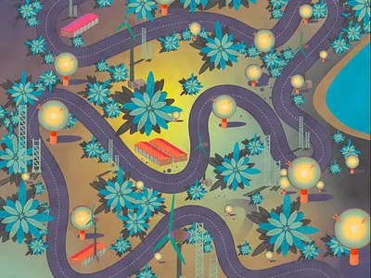

**GK Corner**

**1.** *What instrument is used on a map to show directions?*  
**Answer:** Compass

**2.** *Which type of map shows natural features like mountains and rivers?*  
**Answer:** Physical Map

**3.** *What is the name of the 0° line of latitude?*  
 **Answer:** Equator

**4.** *What do we call a book that contains a collection of maps?*  
**Answer:** Atlas

**5.** *What is the purpose of a scale on a map?*  
**Answer:** To show the ratio between the distance on the map and the actual distance on the ground.